Jones, Kathy (from Linked In)

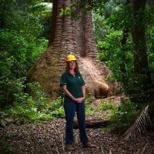

BSc Forestry ANU. University of Technology, Sydney Executive MBA.

Regional Manager Central Region Forestry Corporation of NSW 2013.

.

